1. Introduction 3
2. Objective Description 3
3. Methodology applied 3
4. Business Understanding 4
4.1 Business Objective 4
4.2 Assessing the Situation 4
4.3 Determine Data Mining Goals 4
4.4 Project Plan 5
5. Data Understanding 5
5.1 Initial Data Collection 5
5.2 Data Description 5
5.2.1 Primary Variables 5
5.3 Data Exploration 7
5.3.2 Primary Variables - MBA on Recency 11
5.3.3 Secondary Variables Visualization 12
5.4 Verifying Data Quality 25
6. Data Preparation 25
6.1 Data Selection 25
6.2 Construct Data 33
7. Knowledge Discovery 34
7.1 Clustering 34
8. Modelling 35
8.1 Modeling Techniques 35
8.2 Test Plan 35
8.3 Building Model 36
9. Evaluation 49
9.1 Evaluate Results 49
9.2 Review the process 49
9.3 Iterations 49
Appendix – A 51

Introduction
A Mail-Order company has a product they would like to promote. They consider a campaign offering this product for sale, directed at a given customer base. Normally, about 1 % of the customer base will be „responders“, customers who will purchase the product if it is offered to them. A mailing to a million randomly-chosen customers will therefore generate about 10,000 sales. A more efficient marketing is performed by using data mining techniques.

Objective Description:
The objective of the project is to use Data mining techniques to identify potential customers who would respond to the campaign. Since the customer base is large, an increase in the response rate from the earlier 1 % to 1.5% can reduce the cost of mailing by one third because then 1000 sales can be achieved by 666,667 mailings itself.

Methodology applied:
We have used Cross-Industry standard Process (CRISP) methodology for data mining in order to achive the project objective.
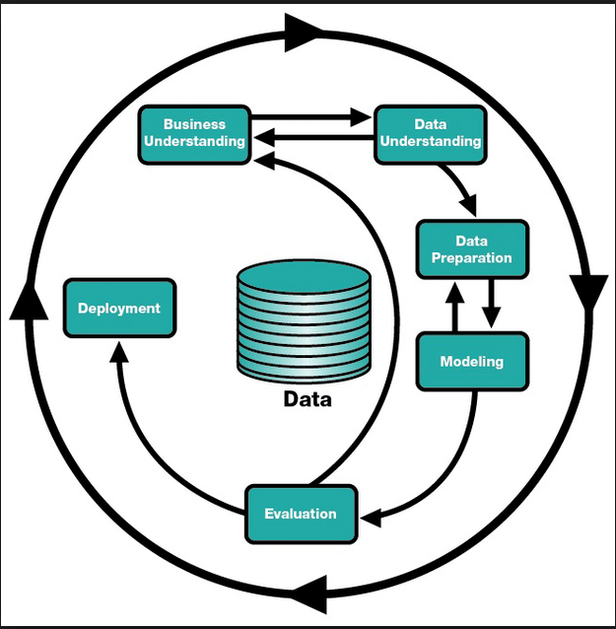
As we can see in the above diagram the CRISP methodology uses the following 6 steps:
- Business Understanding
- Data Understanding
- Data Preparation
- Modeling
- Evaluation
- Deployment
As shown in the above diagram the phases in CRISP methodology are iterative and are repeated multiple times depending on the evaluation result.
Please find below the detialed explanation of each phase of CRISP methodology.
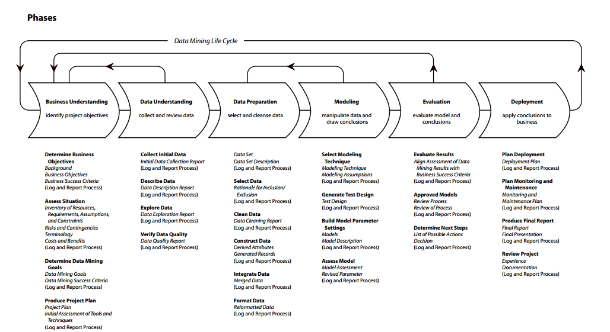

Business Understanding

Business Objective
The goal is to improve the response rate of customers in the mailing campaign conducted by the Mail-Order Company. Thus, reducing the cost of mailings to the customers by identifying potential customers who are likely to respond.

Assessing the Situation
The data is available in the form of a file named project.csv. The file contains the list of the 1% responders (1079) together with 1079 randomly chosen non-responders. A total of 2158 cases are available. The software used for building the model is R and Rattle. The data is adequate with representation of all possibilities i.e customers who have responded as well as customers who have not responded to the mailing campaign. The quality of the data will be analyzed using the tools.

Determine Data Mining Goals
The data mining goal is to improve the response rate of the customer by applying data mining techniques to identify the customers most likely to respond and target those customers. The goal is to increase the response rate to 1.5% from 1 % , by doing so we can target 1000 customers by 66,666 mailings only. Therefore reducing the mail cost by one-third.

Project Plan

Please find below the data mining project plan details.
Business requirement: 15%
Data Assessment: 25%
Data Preparation: 35%
Modelling: 15%
Model Evaluation: 10%

Data Understanding
We have collected the initial data from the csv file provided. The dataset is complete as it covers all the possible scenarios. We have got a set of 200 variables. The variable set were divided into multiple sections and each section were examined and analysed for their statistical properties.
The basic statistics were applied on the variables to find anomalies, outliners and noise. The relationship and correlations between various attributes were examined and the variables with high correlation values were deemed redundant and hence discarded.
The various visualization techniques such as Bar chart, Histogram and Box plot were applied to the initial dataset to formulate initial hypothesis .Based on the initial hypothesis, certain datasets were selected for further examination.
The data was further examined for its data quality. The attributes with noise and high level of skewness were dealt with the help of various transformation techniques like log and rescaling.

Initial Data Collection and Data description:
The data was collected from the csv file provided. The first 24 variables from V1 – V24 are the primary variables and are directly related to customer’s profile. V35-V136 form the census variable, and v145-v199 are demographic "taxfiler" variables.

5.2 Data Exploration

Primary Variables:
The variables v1 – v24 are directly related to the customer’s profile, showing his spending on various products, transactions made by the customer and the recency with which he purchased the different products. Hence these are considered very important and informative. The following are the comments on these fields:
- Product recency for product 5 and 10 is missing in the given data set.
- The recency variables are positively skewed except product 3 recency and product 15 recency, which are negatively skewed.
- All the product recency variables are highly dichotomous (i.e. the data set is either grouped close to 0 or close to 1). Hence we are making it as flag variable and assigning 0 and 1 values.
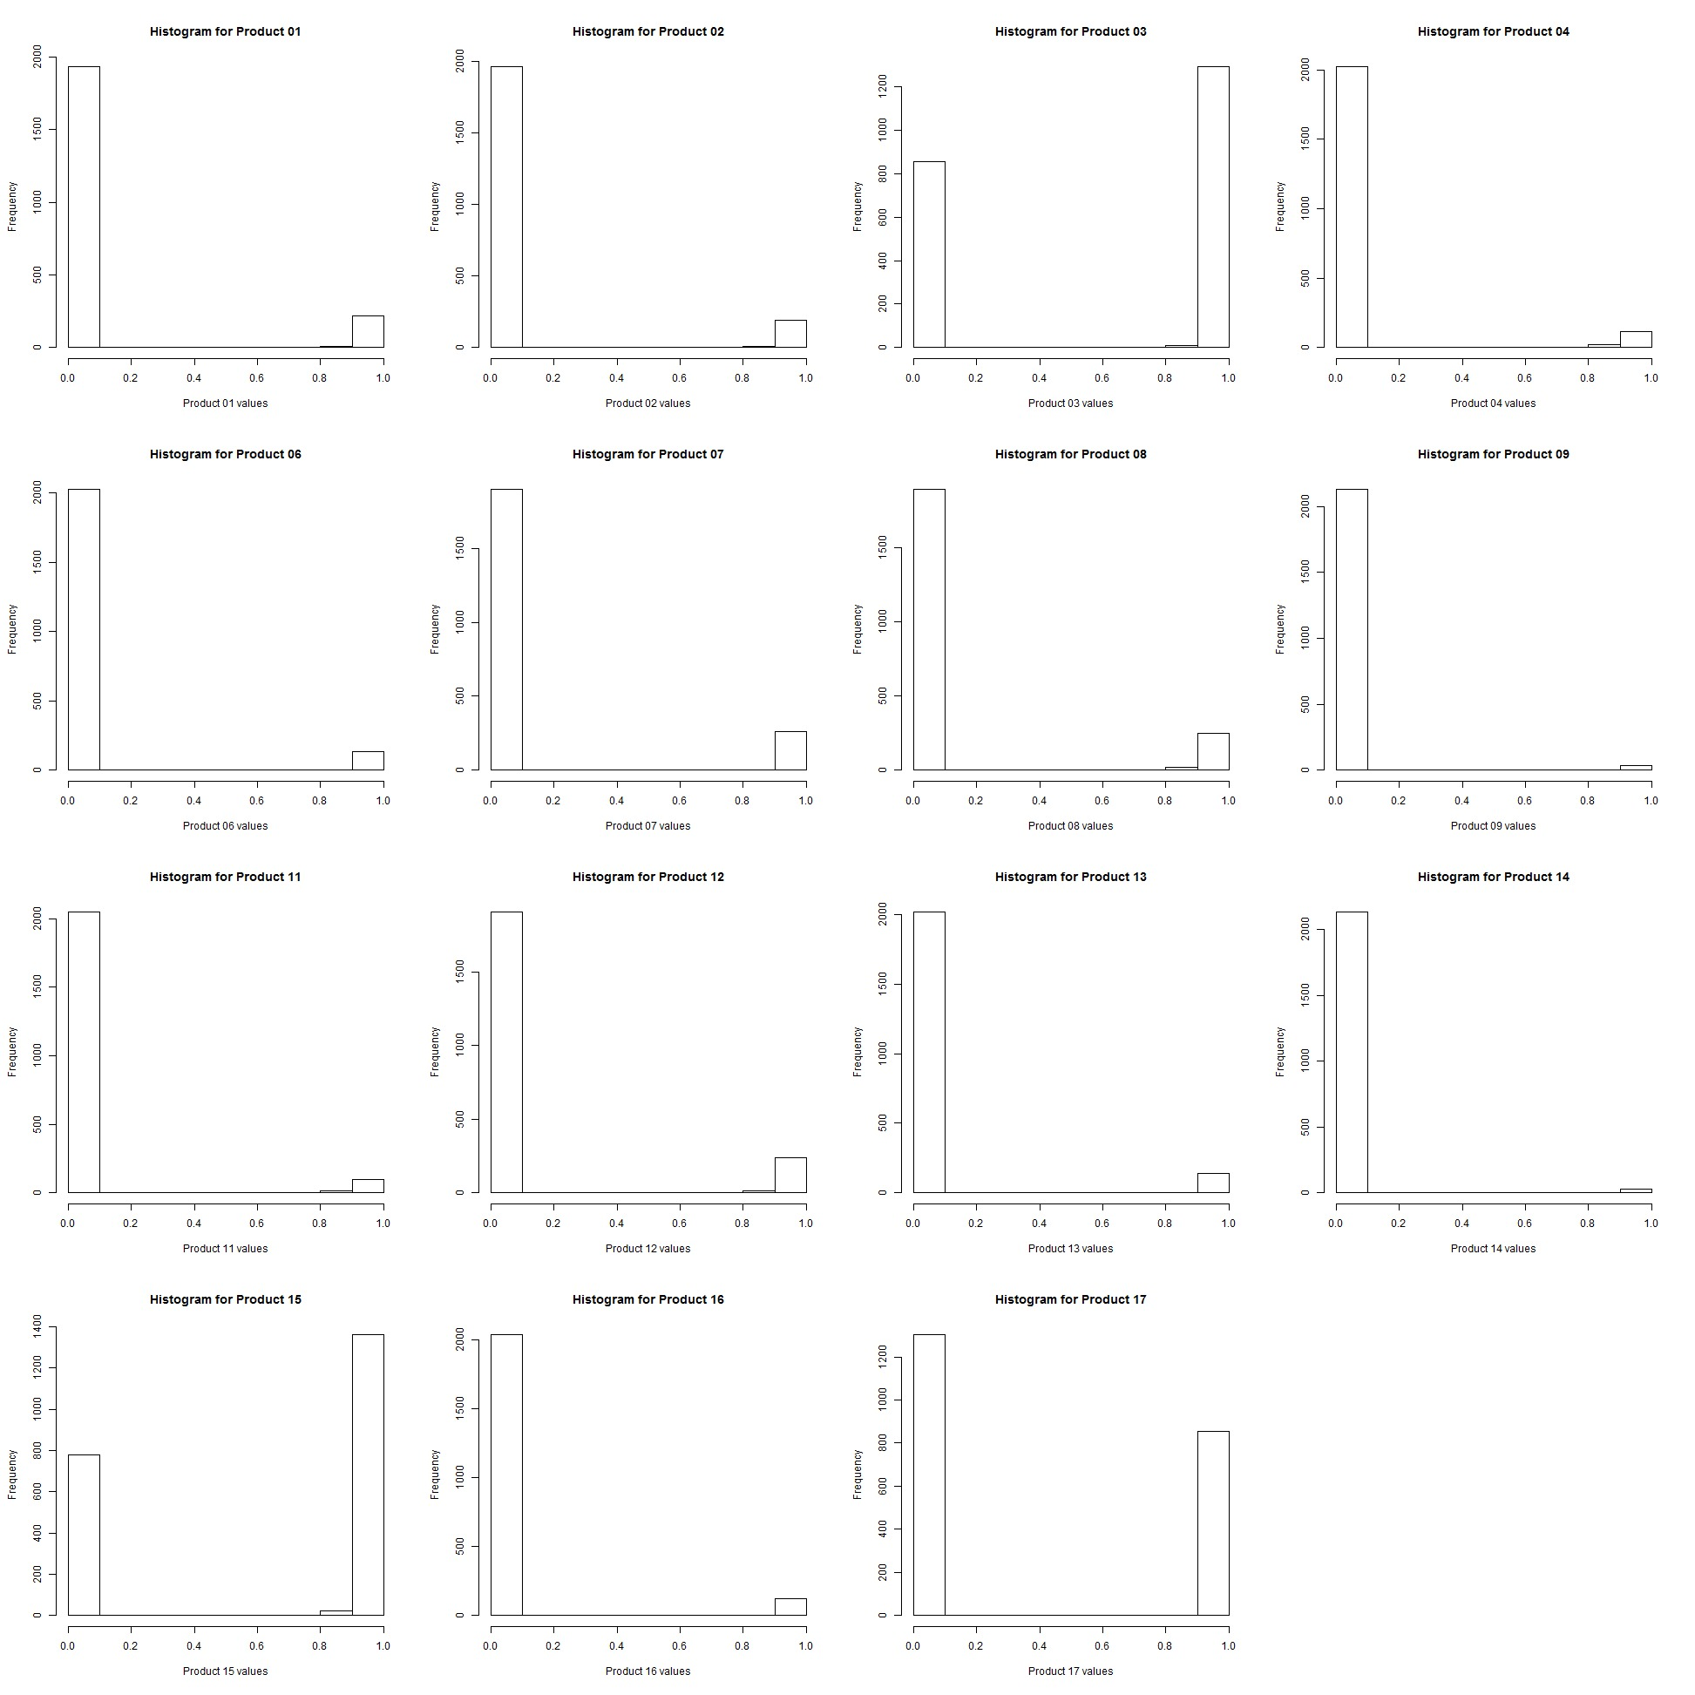
Further visualisation was performed on “Total spend” and “total transaction” .
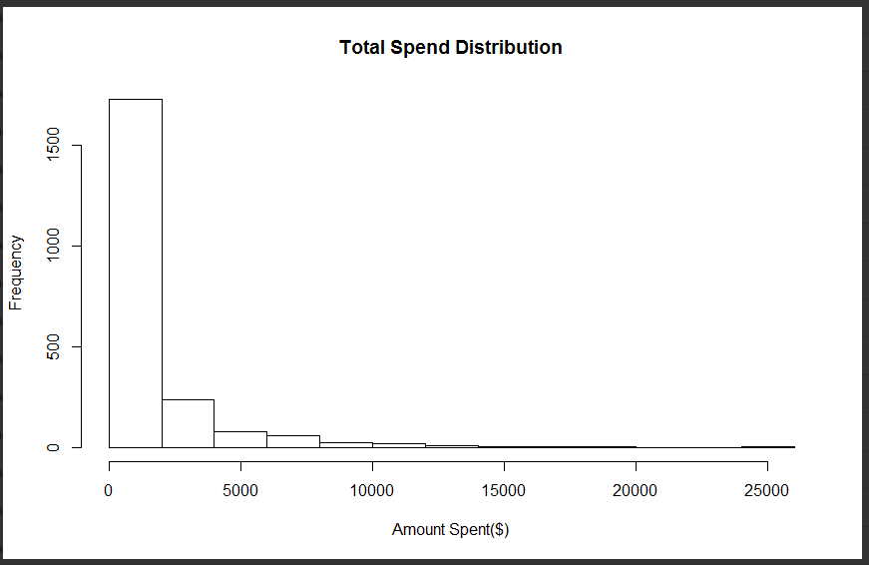
We have plotted histogram of total spend and found that the number of high spenders are very few as compared to the number of low spenders.

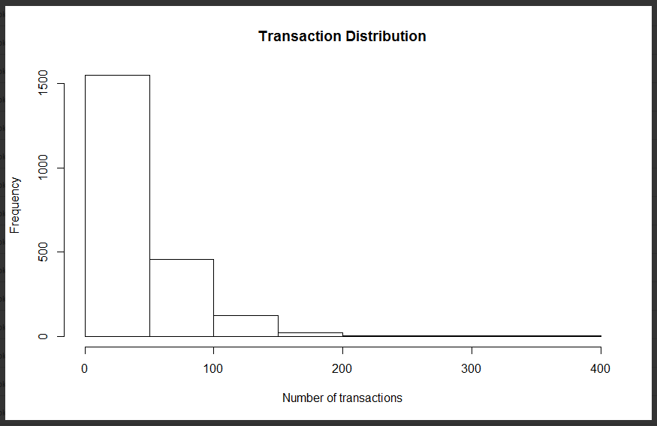
We have plotted above histogram of number of transaction .There are very few customers who are having high transactions. Thus from the above two histogram we can conclude that very few customers are willing to make high number of purchases or spending high sum of money.

5.3 Data Transformation
5.3.1 Derived Variable:
Please find below the list of derived variable and there transformation rule.

Variable after transformation | Formula for transformation
Number of distinct products purchased | Sum of number of product recency withy non zero value for a given customer
Most recent purchase | The lowest non zero value of all the product recency
Average Spend | Total spending/Total Transactions (Indicates the potential profit the customer may generate to the company)

The number of distinct products purchased histogram shows that most of the customer buy around 1 to 2 distinct product and very few customer buy multiple distinct products. The data distribution is highly skewed towards right.
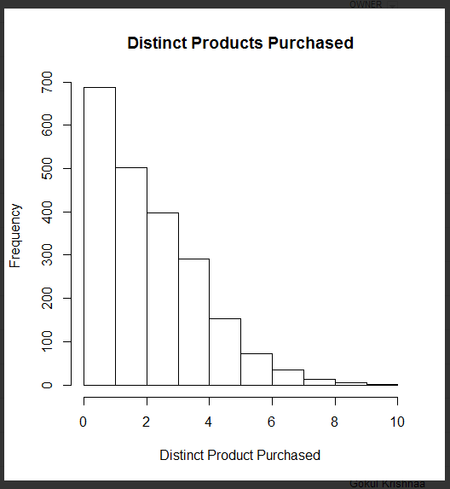

The number of distinct products purchased vs response histogram shows that as the number of distinct product goes higher the probability of a customer to response to mail campaign also increases. We can therefore use this factor in order to predict customers likely to respond.
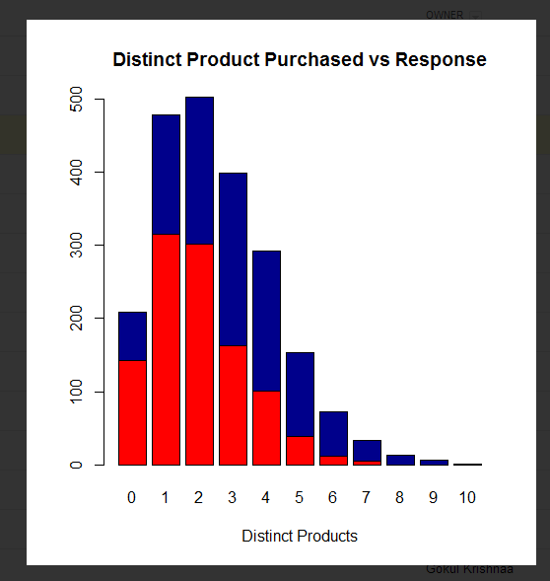

The below histogram between most recent purchased product and response does not provide any valuable information regarding the likelyhood of a customer to respond.

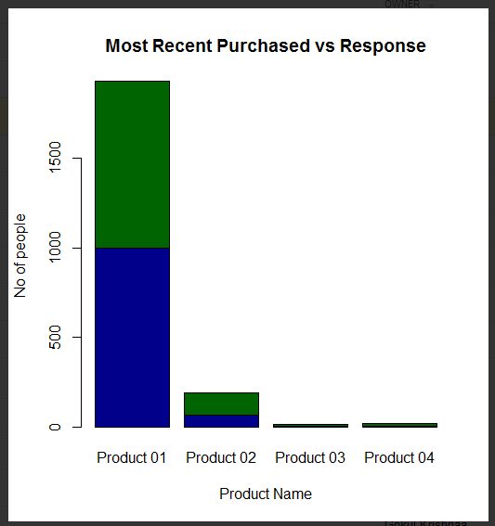

5.3.2 Transforming Numerical variables to Categorical variables:
We have used some of the numerical variables and converted them to categorical variables. This transformation will help us in reducing the variables while maintain the meaning of the overall data leading to much smaller and richer set attributes.

Numerical Variables | Categorical variable generated
tf46 Total earn T4 < $15,000  tf47 Total earn T4 $15,000 to $24,999  tf48 Total earn T4 $25,000 to $44,999  tf49 Total earn T4 $45,00 and over | Total earn
amtenglish and amtfrench | Mother tounge
betmulti and betsingle | Ethnic originSngMul
bmps and bfps | PstSecondryQualificationMF
bfsllabf and bfslplabf | LnPrntLbrFrcMemONonMbr
bimprovres and bimuk | Immigrants
binf30plus and binf7to15 | IncFem15Plus
bknenglish and bknfren | KnwOffLng ( knowledge of official language)
"Total taxfilers with interest & other investment income from $1 to $499","Total taxfilers with interest & other investment income from $500 to $4999","Total taxfilers with interest & other investment income from $5000 to $9999"&"Total taxfilers with interest & other investment income from $10000 and up" | IntrInvstInc
bndtbusser and bndtgovser | SerIndBussGovn
bdwmaint ,bdwmajor and bdwminor | DwellRepMaint
betbritish ,betenglish and betfrench | EthOrgn(Ethnic Origin)
bfi20to35,bfi50plus and bfiinca | FamInc
bhi20to35,bhi50plus and bhiu20 | HHoldInc
bhlenglish,bhlfrench and bhlnonoff | HomLngEngFrhNonOff
binm15to30,binm30plus and binm7to15 | Mal15PlsInc
"Total who claimed tuition credit","Total who claimed charitable donations" and "Total who claimed move credit" | ClaimTutDonMove
tf28 The number of taxfilers with income from $1 to $14,999  tf29 The number of taxfilers with income from $15,000 to $24,999  tf30 The number of taxfilers with income from $25,000 to $34,999  tf31 The number of taxfilers with income from $35,000 to $44,999  tf32 The number of taxfilers with income from $45,000 to $54,999  tf33 The number of taxfilers with income from $55,000 to $74,999  tf34 The number of taxfilers with income from $75,000 to $99,999  tf35 The number of taxfilers with income from $100,000 to $149,999  tf36 The number of taxfilers with income from $150,000 and over | TaxfilerInc
bsl9to13nc ,bslg9 ,bslnunivc,bslunivdeg ,bslunivnc ,bslunivnd | EduQual
brlanglic,brlcathol,brlprotest,brlrcathol and brlunited | Religion
bocffabric,bocfmanage,bocfteach,bocmmanage and bocmscieng | LineOfWrk
bmoy1intep,bmoy5intep,bmoy5intrn,bmoy5mov and bmoy5non | Mobility

